Machine Learning Project
The approach specified by ML Design Template - ML Interviews (no date), one of the reading materials from Unit 1, is used as reference for this exercise.
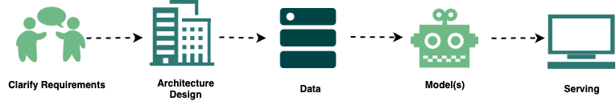

Requirements
The agreed business question for the project is:
Can a neural network predict NYC Airbnb listing prices more accurately than classical regression, and which listing features drive its predictions?
- Scale of the problem: The project uses AirBNB dataset for the New York region. The dataset contains 48,895 records, with 16 attributes for each record.
- Hardware constraints: Considering the project is commissioned as part of academic study, the team do not have access to extensive hardware. Accordingly, the project is executed more from a theoretical exploration and knowledge gain perspective.
- Model constraints: The objective of the project is to gain knowledge of machine learning processes. Accordingly, the team will approach the work from the perspective of knowledge gain and experimentation, as against building a productionised software. Nonfunctional requirements like scalability considered as out of scope.

Architecture
One of the key aspects of designing deep neural networks is to decide on the depth, or the number of hidden layers within the neural network. For current scenario, we will attempt a 2 and 3-layer deep neural networks.

Data
The task uses the AirBNB dataset for New York region. A copy of the input dataset is maintained on the team’s shared drive under ~/Group B - Machine Learning/Input data
- Target variable: Since the aim of the project is to analyse the prediction of price, the price attribute will be considered the target variable. Since the price data is present within the supplied input dataset, there is no need to undertake separate labelling exercise.
- Features and feature crosses: Feature engineering forms a key part of machine learning. However, the approach differs depending on the type of machine learning approach. In case of classical ML, a human is required to pre-select the features that the ML model needs to consider. In case of deep learning, it is better to supply the neural network with raw, full dataset. As Dhar (2025) discovered, patterns emerge before reasons for them become apparent.
- Data cleanup: Prior to using the data, we need to do some data cleanup where required. For example, there are 11 rows with price as 0 – we will discard these rows before using the data for training and testing.
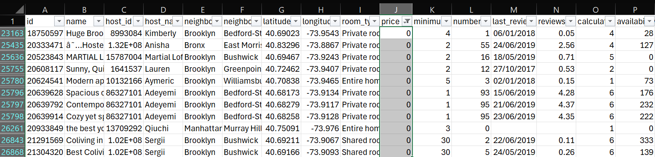
Additionally, we will discard few of the columns like id and host_id. These are technical identifiers for the rows/entities, so should not be related to price in any way.
- Preparing training and testing datasets: To assess fitness and accuracy of the model we have designed, we need a subset of data that was not part of the model training – in other words, a dataset that is unseen by the model. For this purpose, we will split the AirBNB dataset into two parts, with 80% for training and 20% reserved for testing.

Modelling
As specified within the architecture section previously, we will try a 2 and 3-layer neural networks. The Python code for the model can be found under the GitHub repo https://github.com/mscaimh/ deep_learning_ab_nyc_2019.
Training dataset
Metric | 2-Layer | 3-Layer
Trainable params | 39,041 | 41,153
MAE | 62.18 | 58.27
RMSE | 215.31 | 195.34
R² | 0.1936 | 0.3362

Testing dataset
Metric | 2-Layer | 3-Layer
MAE | 67.35 | 64.61
RMSE | 224.61 | 232.67
R² | 0.1369 | 0.0738

Looking at the results, the 3-layer model does slightly better in terms of mean absolute error (MAE), however the 2-layer model fairs better on the other two. Overall, it looks like the 3-layer model overfits the training dataset. This is a well-known phenomenon within ML, that deeper model does not necessarily translate to better results. It is critical to experiment and identify optimal depth of the neural network.
Now we try to assess impact of features on the price. We will use the 2-layer model. Removing the room_type feature causes the error rate to increase the most. This indicates to us that the room_type feature is the strongest predictor of price.
Rank | Feature | RMSE increase
1 | room_type | 17
2 | availability_365 | 10
3 | neighbourhood | 8

Classical regression model
Now let us create a classical regression model for comparison. Unlike deep learning, building classical regression requires a human to decide the features to use. For consistency of comparison, we will use our learning from the deep learning exercise. Consequently, let us use the 3 top features, room_type, availability_365 and neighbourhood, which were found to be having the most impact on predicting price. Let us use linear regression for simplicity.
Training dataset
Metric | Linear regression
MAE | 69.97
RMSE | 225.76
R² | 0.1134

Testing dataset
Metric | Linear regression
MAE | 72.72
RMSE | 227.97
R² | 0.1108

Comparing the neural network with the linear regression model
Comparing the 2-layer deep neural network and classical regression models for results against testing datasets, the neural network appears to do better overall.
Testing dataset
Metric | 2-Layer | Linear regression
MAE | 67.35 | 72.72
RMSE | 224.61 | 227.97
R² | 0.1369 | 0.1108

Serving
In a typical productionised ecosystem, the model can be served by deploying onto a service like Amazon Web Service’s Bedrock or Azure’s Foundry.

References
Dhar, V. (2025) Thinking with machines : the brave new world of AI. 1st ed. John Wiley & Sons.
ML Design Template - ML Interviews (no date). Available at: https://www.machinelearninginterviews.com/ml-design-template/ (Accessed: 23 May 2026).

